 | TALLRITE BLOG | Issue # | 160 | Sunday | 19th August | 2007

- What Is Morality?
- Electricity and Money - An Iraqi's Solution
- Anti-Smoking Nannies Escape from the Nursery
- Week 160's Letters to the Press
- Quotes of Week 160
What Is Morality?
Last week's lead post was about illegality and immorality in Iraq. But what actually is “morality”?
For most of us it means, in broad terms, a distinction between right (“moral”) and wrong (“immoral”). In practice, we tend to concentrate on what is wrong, and conclude that if it's not wrong it's right. Right? For instance, eight of Christianity's Ten Commandments begin with negatives: “Thou shalt not [kill, steal etc]...”
Perhaps there are many more good acts you can do than bad ones, so it's easier to concentrate on the bad. However, I (unlike, evidently, God) am reminded of author Michael Losier's admonishment never [sic] to use the words “don't, not and no” because their negativity not only fails to convey what is actually required, but also draws attention to the unwanted. (Admit it - what picture does “Thou shalt not commit adultery” conjure up in your mind? Be honest!)
But, returning to the bad stuff (that we all enjoy, in the movies at least, if not so much in real life), this seems to fall into two categories.
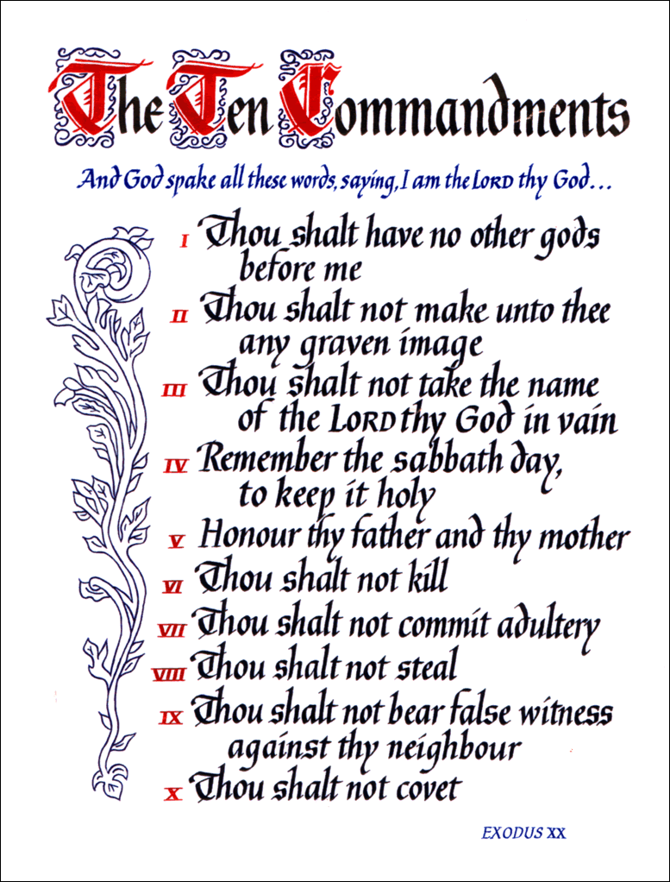
Into the first category fall what I would call natural wrongs. These are things that “feel” intrinsically evil, regardless of your culture, religion or upbringing. I can't prove it, but I think there must be no groups of (sane) humans anywhere that think it is OK to steal from or kill other people within their own community on a whim. I mention “own community” and “whim” because these can often provide excuses or reasons to justify actions that would otherwise be considered wrong. For example,
- I killed him, but this wasn't wrong because he was from another tribe or religion, or
- I executed him, but only as a punishment for his crimes, or
- I stole from him, but purely because my children had no food.
Take away the excuse, and I very much doubt that the individual would consider the killing or stealing to be acceptable.
Such natural wrongs don't seem to be very many in number. I reckon if I can only desist from killing, injuring, raping, robbing, defrauding and deceiving people, I can start living to a pretty high moral standard. The key determinant that makes these things wrong is one ingredient: other human beings. In every case they inflict harm, to varying degree, on another person.
Maybe I should also put a stop to my habit of needlessly killing and injuring animals. This would certainly be virtuous, though I am not sure I would consider such acts to constitute “natural” wrongs (after all, foxes in chicken houses don't).
Nevertheless, apart from the animal thing, I think we can all agree about the natural wrongs.
But for many, including Christians, Jews and Muslims, the moral code extends equally to other matters. Well, just two other matters.
The first is suicide. Is this a natural wrong? I don't think so. No-one is harmed but yourself (although your family will be pretty upset), but if you don't have the right to your own life, then who does? An intrinsic right to life surely includes a right to terminate it.
And yet we all hate the idea. Certainly, from an evolutionary point of view it makes sense to abhor suicide, especially if you are of child-bearing/rearing age, as it damages the survival chances of your genes. But this is a dangerous argument, without a moral dimension, because it would then advocate raping any and every woman you could find in order to maximise your DNA propagation.
Which brings me to the second other matter - sex. It's both right and wrong.
- Right within marriage, wrong outside it (remember “Thou shalt not commit adultery”?).
- Right when it's consensual, wrong when it's forced.
- Right when it's heterosexual, wrong when it's gay.
- Right when it's the missionary position, wrong when any other variation is tried.
- Right between the same races, wrong between different ones.
- Right without birth control, wrong with a condom.
I could go on, but a couple of things stand out. Firstly, not everyone would agree with this list (no, really!). Secondly, assuming we're talking consensual adults, who - other than the cuckold's feelings - is getting hurt? Why, then, should any non-adulterous sex be classified as wrong? Or suicide?
The answer is that there is no reason based on logic. Rather, one or both of two things intervene.
- People throughout history have always agglomerated themselves into groups (family, gang, tribe, country, race etc), which then draw up particular codes of acceptable behaviour, sometimes backed by legal measures and punishments.
- Most people have always believed in the existence of God(s) and certain rules that he/she has [have] laid down, for instance those Ten Commandments. This is called religion.
These agglomerations/religions then adopt a schedule of morality, “morality map” in my illustration, that proscribes not just those natural wrongs, but several other types of behaviour to be frowned upon. However they make no distinction between the natural wrong and the imposed wrong, and therein lies much of the confusion over what we call morality.
The source of morality, as we understand it, is a mixture of religion, culture and nature, of which religion claims the lion's share, followed closely by culture.
But religion and culture are erroneous in preaching that they are the sole authors of morality, since they ignore the natural order that forbids certain wrongs. Indeed, as the Morality Map shows, they are obsessed with sex, and to a lesser extent suicide.
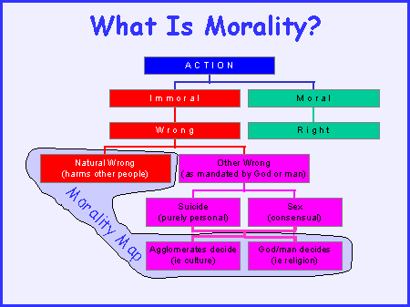
- Thus Christians are brought up with a huge guilt complex over non-marital sex, yet the only explanation ever offered is that non-marital sex and solo sex and homosexual sex and fancy positions sex are all a sin simply because ... God says they're wrong and/or society says they're wrong. Of course there's usually a bit of fluff about self-respect or you'll be sorry in the morning or you'll go blind, but these are not explanations for the wrong.
  - The one exception, arguably, is sex which procreates another human being without providing the full commitment to provide for its upbringing. This falls into the category of natural wrong since it harms and deprives another person - the child.
- Muslims, for similar non-reasons, are taught to obsess over sex. Women must be covered from head to toe, and if they step out of line they can be killed. Men may not meet them before marriage, but on the other hand can marry and divorce at will (even for just one hour) to create an aura of respectability for sex. And all the time, there is that ridiculous lure of 70 or so “virgins” and unrestrained sex for all eternity in the afterlife, that which Mohammed Atta was so meticulous in preparing for prior to leading the 9/11 attacks.
So what is morality?
In the absolute sense it is sticking to the natural law, ie avoiding the natural wrongs. This is a code of conduct that applies universally, to atheists as much as theists, to wildmen in the jungles of Papua New Guinea as much as to sophisticates on the Champs-Elysées.
Yet the additional sex and suicide morality imposed by cultural and religious norms have their place too. But that place is more to do with ensuring an orderly society that the majority of people feel comfortable living in. But breaking those taboos, if it doesn't harm another person, is not really “wrong” is it? A bit like parking in a no-parking zone.

Electricity and Money - An Iraqi's Solution
“The Hammer” is the pseudonym (for security reasons) of a courageous Iraqi interpreter who has been working for several years with the American military. Journalist and blogger Michael Totten recently conducted an exclusive and heart-felt interview with him. It is fascinating on many levels to hear the words of a young Iraqi man so close to military operations, so aware of the calamitous state of his country, so in-tune with the thinking of his countrymen, so patriotic and so astute in recognizing that only the Americans can help.
But two sets of observations particularly caught my eye. Knowing the way his people think and behave, he proposes two remarkably inventive solutions which he believes would go a long way towards pacification of his sorry country. Electricity and money. Here's how.
- Electricity: One hour a day is the average supply in Baghdad and elsewhere, and what do young men use it for? TV and air-conditioning. That cool hour is spent watching Al Jazeera, which constantly urges them to fight. There are plenty of other programmes with different ideas, but no chance to watch them.
If a reasonable amount of power were made available to the population, there would be less heat-induced craziness combined with an injection of fresh, non-propaganda ideas.
- Money: Here the Hammer's ideas is not to give it but to take it. Levy heavy fines - thousands of dollars - against the families of every insurgent captured, killed or otherwise identified. Money speaks louder than words, or it would seem guns, for he reckons the families would soon put a stop to the violence perpetrated by their sons.
I wonder is anyone in the Bush administration picking up on these shrewd ideas.
Read the whole fascinating interview for yourself. Then see whether you agree that such interpreters should be granted residency in the Coalition country they have served.

Anti-Smoking Nannies Escape from the Nursery
Ireland introduced the world's first nation-wide indoor workplace smoking ban in 2004, and it has been an outstanding success, despite (or more likely because of) the lack of any exemptions whatsoever other than in prisons.
- The ban is observed religiously everywhere - even in late-night illegal drinking dens, known as shebeens.
- It is universally popular, even among smokers who say it has helped them give up or reduce their smoke intake.
- Studies have shown that non-smoking workers previously exposed to passive smoking (specifically, bar staff) have exhibited a marked improvement in their health metrics and respiratory condition.
A major factor in its overwhelming acceptance is the way the ban was presented, as something to protect workers who hitherto had no choice but to inhale second hand fumes, rather than as a measure to improve public health. People respond to an appeal to help their neighbours, but instinctively dislike others telling to do something “because it's good for you”.
Nannies should remain in the nursery.
Some fifty countries in six continents have since introduced their own similar bans, to a greater or lesser extent, most recently England last July. But it has been notable how less scrupulous about presentation they have progressively become. By and large, the recent smoking bans have been unashamedly promulgated purely as a public health matter - to hell with the workers. As England's official website proudly proclaims, “A smokefree England ensures a healthier environment, so everyone can socialise, relax, travel, shop and work free from secondhand smoke”.
And some places have gone further and even introduced outdoor smoking bans such as on beaches (Australia), patios (Canada), streets (Japan). Just last week, here in Ireland, I encountered an outdoor smoking ban at a hospital patio. With no pretence that this will improve anybody's health, it is just a bit of smoking fascism to promote a no-smoking ideology. Of course, the whiff of other people's cigarette smoke at the beach is offensive, but so is their boom-box blaring out the latest hits not to mention their barbecue because you're not invited, and no-one is talking about banning those.
Now corporations are leaping onto the militant anti-smoking fascist bandwagon. For example,
- Clarian Health, a renowned Indiana hospital chain with 12,000 employees, will from 2009 dock smokers $5 from their (presumably monthly) paychecks. And if they're also too fat, then, to add insult to injury, they'll lose a further $30 until they get their weight, cholesterol and blood pressure down.
- Another US company in the health business, Weyco stopped hiring smokers four years ago and will fire you if they find out you're smoking at home.
Moreover, according to Mercer Human Resource Consulting, such companies are merely trailblazers for corporate bandwagons to follow in similar vein.
Ireland's smoking ban will long be successful because of its appeal that we spare the health of downtrodden workers by not smoking in their workplace.
In my view, those other, more robust, more ambitious approaches on the other hand, are doomed to failure, one way or another. There is bound to be some kind of backlash because people hate to be forced to do stuff, though they are very amenable to persuasion. I am reminded of Aesop's fable where, in a trial of strength, the Wind failed to remove through blustering force a traveller's cloak, whereas the Sun merely by shining hotly induced him willingly to remove it.
The anti-smoking nannies have, it seems, escaped from the nursery after all. But for how long?

Week 160's Letter to the Press
Just one letter this time, based on a post from last week. But I was not surprised it went unpublished as you're not supposed to make jokes about the Palestinians.
- From North Pole to West Bank
- to the Irish Times
Madam, - If the Russians get away with their claim to a million square kilometres of hitherto stateless real estate beneath the Arctic on the basis of planting their titanium flag on the seabed, and the UN eventually ratifies it, this could set an interesting precedent (“Laying Claim to the Arctic”, Opinion, August 13th).
For the world contains other chunks of stateless land that could be similarly up for grabs by UN member nations. For example, would not a Star of David, titanium or otherwise, then be sufficient to resolve sovereignty over the West Bank?
The Palestinians would do well to conclude a two-state deal quickly before Russian antics snitch the prize from under them. - Yours etc,

Quotes of Week 160
Quote: “I am astonished at those who are afraid of the people: one can always explain that what is in the interest of Europe is in the interests of our countries ... Britain is different. Of course there will be transfers of sovereignty. But would I be intelligent to draw the attention of public opinion to this fact?”
Jean-Claude Juncker, tiny Luxembourg's (pop 0.5m)
long-serving premier
makes the eminently sensible observation that
the British people (pop 61m) should be kept in the dark
about the EU's (pop 490m)
new would-be constitution,
because they're bound to oppose it.
When it comes to ideas
above his station,
Mr Juncker has form.
This is the same man
who famously - and disgracefully - remarked, prior to the French “Non”
and the Dutch “Nee”
in their respective
EU constitution referenda,
“If it's a Yes, we will say ‘on we go’,
and if it's a No we will say
‘we continue’”.
Quote: “Is it fair to slaughter enemy spies?” Answer “Yes”
From “Military Teachings - for the Preparation of Mujahideen”,
a new, 144-page, minutely detailed
field manual by the Taliban
on how to spring ambushes, run spies and conduct an insurgency
against coalition forces in Afghanistan.
It includes helpful advice
on subjects ranging
from tactics and weapons to building training camps and spycraft.
Don't do jihad without it.
Quote: “Scratch a liberal, find a dhimmhi”
Kathy Shaidle, Toronto author, editor, writer and blogger,
comments on the appalling appeal
on Dutch TV of
Breda's Catholic Bishop
Martinus Muskens
to Christians to address God as “Allah”,
presumably in the interests of outreach - rather than of grovelling
Quote: “[Chief Executive of Aer Lingus] Dermot Mannion can't come along on a bank holiday Monday and turn into a latter day Oliver Cromwell” ... “[it's an] Armageddon situation.”
Willie O'Dea, Ireland's laughable Minister
of (laughable, <1% of GDP) Defence,
gets laughably worked up,
simply because Aer Lingus
is transferring a Heathrow route from Shannon to Belfast.
In Ireland, Cromwell,
the seventeenth century English
republican leader
is synonymous with brutality
and wide-scale massacres.
Armageddon is the mythical final
climactic battle
between God and Satan
Quote: “I don't want a baby drinking from me - the thought of it makes me feel really funny. I think there's only a certain person could handle my knockers!”
Supersize mammalia Jordan makes clear
her giant glands have only one purpose,
and it's not feeding infants
