 | TALLRITE BLOG | Issue # | 163 | Thursday | 18th October | 2007

- Burma and How to Boycott the Chinese Olympics
- Agricultural Protectionism and Confiscatory Subsidies
- Chatting Whilst Asteroid Collides
- My (ahem) New Crime Novel
- Issue 163’s Letters to the Press
- Quotes for Issue 163
Burma and How to Boycott the Chinese Olympics
We have all been alternately
- exhilarated by the pictures of brave Burmese Buddhist monks peacefully protesting fuel increases and other anti-Junta grievances in the streets of Rangoon and other cities, and then
- horrified to learn of the arrests, suppression, torture, killings and secret cremations that followed, in the best traditions of 1989 Tiananmen Square as exemplified, advised and trained by the Chinese politburo.
The litany of Burmese grievances is familiar to us all; the fuel price hike is just a symptom.
- Since 1962, the country has been run as a tyrannical and incompetent dictatorship under a military Junta, currently headed by General Than Shwe.
- All opposition is brutally crushed.
- The media are all State run and controlled.
- Internet access is severely restricted to impede access to and communication with outside news sources.
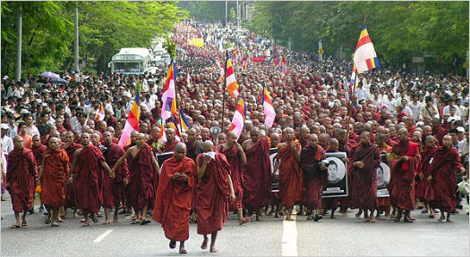
- A 1990 multi-party election was annulled because it was overwhelmingly won by the National League for Democracy led by heroine Aung San Suu Kyi, who has been under almost constant house-arrest ever since.
- China, India and other states in the vicinity happily plunder the country’s abundant natural resources (timber, gems, oil), with proceeds going to the Junta whilst most people subsist on $1 a day.
- Forced prison labourers/slaves are worked ten-hour days on roads and infrastructure, for food only.
- Ethnic minorities, particularly the Karen and the Shan, are genocidally oppressed, forcing many of them to flee as refugees to next-door Thailand and Bangladesh.
The Junta is a vile regime, whose only saving grace is perhaps that it does not have aggressive designs on its neighbours. The generals merely wish to consolidate and hold their own power in perpetuity and thereby to continue pillaging the national treasure for their individual personal enrichment and pleasure - as this wedding of Than Shwe’s daughter illustrates [in this video clip].
The world community is outraged by the Junta’s latest antics against the monks, but outrage is pointless unless you also take action. And there’s the rub.
The US has imposed sanctions on Burma since 1990, directed mainly at the individual generals, but they have had little effect. The generals, few educated beyond primary school level, are just not interested in foreign travel, so barring them from shopping in New York doesn’t do much. Meanwhile, China and India have been delighted to carry on trading, and they have kept the regime economically propped up. So the soldiers have remained ensconced in power, Ms Suu Kyi locked up, and democracy a distant dream. China has long been Burma’s de-facto defender.
Stronger action by the Security Council has up to now been firmly vetoed by China, egged on by (of course) Russia. For obvious reasons, these two states are distinctly uncomfortable at the thought of having to encourage democracy anywhere.
However, the latest crackdown has embarrassed even China, to the extent that the UN Security Council at last, unanimously, “strongly deplores [Burma’s] use of violence against peaceful demonstrations”, as does the UN Human Rights Council (the original text said “condemns” but China and Russia negotiated this down to the weaker “deplores”).
However, the UN statements are pretty toothless. The two Councils urge the Junta to fix Burma’s political, economic, humanitarian, and human rights issues, talk to Ms Suu Kyi, blah, blah, blah, but with absolutely no action to follow should the generals do nothing.
There is a brutal truth about Myanmar that few want to acknowledge.
Justice will only visit Burma once the generals are gone from the scene forever. But they are never going to voluntarily relinquish their power. It’s going to have to be prised from their clenched fingers, and there are only two ways to do this.
- The obvious way is forcible regime-change, a military option which, given that the thuggish Burmese soldiery have never faced an adversary more formidable than an unarmed woman or monk, would probably be quicker and easier than even Saddam’s overthrow. But only the west can or would do this and that of course means America (again). It is a horrible prospect, and might the democratic aftermath turn out to be just as “amicable” as Iraq’s?
- The only other way is to bring China in to play, because it is China (and to a lesser extent India) that is keeping Burma alive and the generals comfortable. China is, effectively, the only country that can overturn the Junta peacefully, simply by growling and turning off the cash spigot. But will the Chinese dictatorship do it? Not if they can possibly avoid it.
Thus, the wider world needs to find the means to encourage China to shunt the Junta aside, without bullets or bombs, so as to allow the democracy to flower in Burma that it’s people voted for in 1990.
But China is such a massive and growing economic power, whose economy is irretrievably linked through vast trade with the West and the rest of the world, that it is hard to dream up non-trade ways to encourage it to do what it has to do.
However there is one point of weakness, and that of course is the 2008 Olympic Games, to be hosted by Beijing, a project to which the Chinese dictatorship attaches enormous prestige.
People have called for a boycott, or a threat of a boycott, as a means to create pressure on China. But this is fraught with its own difficulties.
America boycotted the Moscow games in 1980 in protest at the Soviet Empire’s invasion of Afghanistan. But
- it was the only boycotter,
- the games went ahead,
- America won no medals,
- the USSR remained in Afghanistan and
- in retaliation the USSR boycotted the 1984 games in Los Angeles.
Nothing was achieved except ill-will and a lot of very unhappy athletes prevented from competing globally during the five year long spat, not to mention millions of sports fans forcibly precluded by American and Russian leaders from seeing a truly global competition. Talk about punishing the innocent.
This time around, a boycott of Beijing will only be effective if supported by large numbers of countries (ie EU plus USA). But who can seriously see that happening? And again, innocent athletes will be the main casualties, although in the unlikely event that a lot of Western countries do indeed participate in the boycott, the would-be Olympians will be joined in misery by the Burmese Junta.
But there is another way; another more democratic way involving personal empowerment. Let the games go ahead. Let no athletes be denied their chance to prove they’re the world’s best.
Instead, it is the spectators who should boycott the games. No individual who believes that Burma ought to be liberated should attend these games, or they should at least threaten not to. Banners and bumper sticks that say Free Burma, are very nice but achieve zero. But here is a way that regular folk can effect real change.
For, from the Chinese perspective, worse even than a few countries not showing up in Beijing will be TV pictures, beamed across the world, of empty stadiums whilst the contests proceed, and everyone knowing why. This would be the ultimate, unthinkable humiliation for the Communist dictatorship in China, where “face” is such an important part of national culture, history and psyche. And it would be made grimmer by the knowledge that no Government had done it; just ordinary free people with honourable principles.
If we can all convince the Chinese leadership that a popular boycott of the Beijing Olympics is really going to happen next year, they will move heaven and earth to prevent it.
Or more particularly, they will move the Burmese Junta out of Rangoon and into obscurity, to make way for Ms Suu Kyi or whomever the beleaguered Burmese people elect to govern them.

Agricultural Protectionism and Confiscatory Subsidies
Last week I had the dubious distinction of being invited on Irish TV’s weekly Questions and Answers programme to make a contribution from the floor about importing Brazilian beef. This is a hot topic because Brazil with 200 million cows potentially represents a major threat to Ireland with only 6m. So the agricultural lobby argues that Brazilian beef should be banned because it is “unsafe”, being riddled with foot-and-mouth, mad-cow disease, blue-tongue and God knows what else.
In May, the the Irish Farmers’ Association visited Brazil and reported back that there is unrestricted movement of infected cattle and a lack of traceability, therefore Brazilian beef is not safe and should be banned from Ireland.
However the European Commission promptly rubbished their report, pointing out that the IFA had visited only two States which are already banned from exporting beef to the EU, and a third which is only partly authorised. In addition, the IFA did not visit any slaughterhouses, laboratories or veterinary offices. Therefore, the IFA have no basis for their conclusions.
Invoking “safety” is an old and familiar ploy designed to shut down discussion, but safety standards can be looked at in two ways.
- There are statutory standards designed to ensure that food is disease-free, pest-free and fit for human consumption.
- It’s a bit like ensuring a plane will fly from A to B without
crashing, while saying nothing about the pleasure or otherwise
of the experience.
- But often there are additional standards imposed or adopted within a given environment. For example, in Ireland, following an admirable lead set by one of its smaller chains, all supermarkets, very many butchers and even some restaurants now provide DNA traceability of all indigenous meat back to the originating animal.
- In the aircraft analogy, this represents business-class, or even
first-class service.
The “safety” argument advanced by the Irish lobby places a lot of emphasis on traceability and other qualities in the second category. But desirable as such qualities are, they do not really make the difference as to whether or not your fillet steak will make you sick or kill you. That’s the job of the first category. Meeting statutory minimum standards (category 1) should not be confused with attaining maximum standards (category 2).

The reason for objecting to the importation of Brazilian beef boils down to a very familiar refrain: protectionism, pure and simple. It has nothing to do with the interests of the consumer and everything to do with those of the agricultural community, though they number just 5% of the EU’s population.
That’s why I argued (however ineptly) against a ban in that TV programme, where no-one else mentioned the long-suffering consumers who make up the other 95%.
Provided Brazilian beef meets the same minimum (not maximum) standards required of any other beef import, and so long as its country of origin is clearly labelled so customers can choose whether they want to buy it or prefer more expensive and arguably better Irish meat, there is no case for banning such imports. To do so would have consumers propelled into the wider trap of EU protectionism under the disastrous Common Agricultural Policy, which
- confiscates €400 in extra tax from each EU family in CAP subsidies to farmers and agricultural behemoths,
- adds a further €400 to each family’s annual food bill because of higher prices,
- fosters further poverty in the developing-world by penalising farmers - such as those in Brazil - through denying them access to lucrative EU markets,
- and, most perniciously, turns EU farmers into social welfare recipients to the tune of 60-80% (minute 8) of income in the case of Irish farmers.
That’s the vicious cycle EU citizens and politicians should be trying to break in the interests not of the EU’s 5% of population who are employed on farms but the 95% who are consumers.
Note: Those annual figures €400 + €400 per family (of four) are calculated from BBC estimates of CAP costs as at 2003 divided by the EU’s 2003 population of 485m.
José Manuel Barroso, European Commission president, recently observed that the CAP budget has long been reducing as a proportion of the EU budget
- from 61% in 1988
- to a projected 32% in 2013.
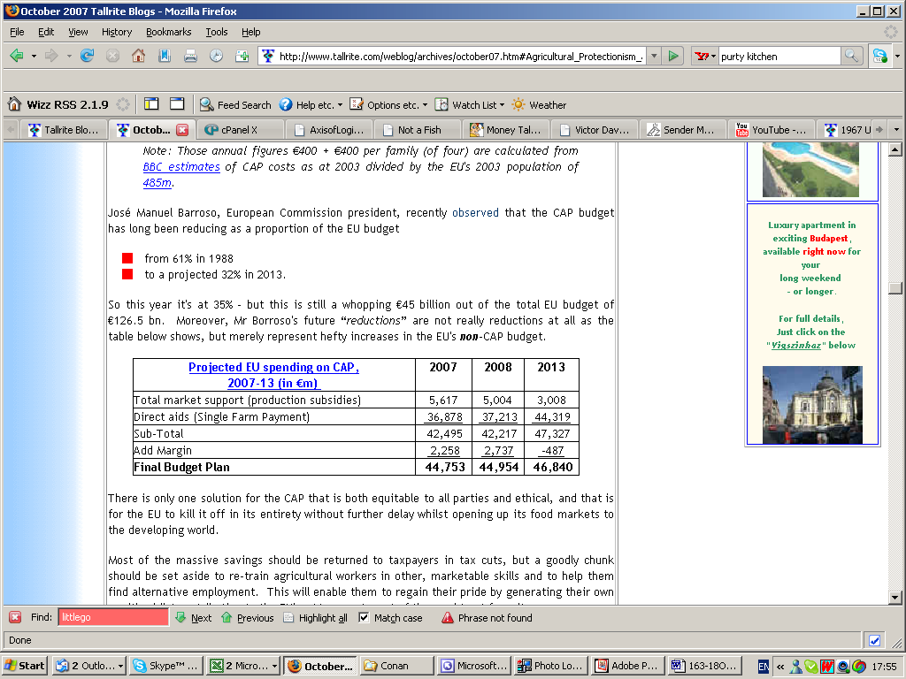
So this year it’s at 35% - but this is still a whopping €45 billion out of the total EU budget of €126.5 bn. Moreover, Mr Borroso’s future “reductions” are not really reductions at all as the table below shows, but merely represent hefty increases in the EU’s non-CAP budget.
Source: Ireland’s “Farmers Journal”
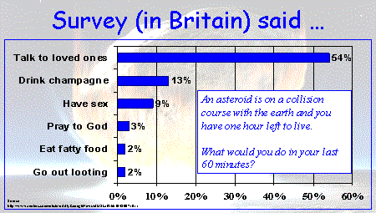
There is only one solution for the CAP that is both equitable to all parties and ethical, and that is for the EU to kill it off in its entirety without further delay whilst opening up its food markets to the developing world.
Most of the massive savings should be returned to taxpayers in tax cuts, but a goodly chunk should be set aside to re-train agricultural workers in other, marketable skills and to help them find alternative employment. This will enable them to regain their pride by generating their own wealth whilst contributing to the EU’s. At present most of them subtract from it.
It should then be up to each individual state to decide how to manage and fund the maintenance of its countryside in accordance with taxpayers’ desires. That’s not Brussels’ business.

Chatting Whilst Asteroid Collides
Reuters must have too many journalists with too little stuff to report. What else explains the story I have converted into this chart?
Go looting? Why?
My (ahem) New Crime Novel
Set in a leafy and expensive suburb of south Dublin, here’s an extract. Is it a page-turner, or what? The movie rights are available for the right price.
Charlie Chawke, the popular and well-known landlord of The Goat Grill pub and restaurant, left the building with a bag of takings amounting to nearly fifty thousand €uro in cash and cheques.
As he was getting into his silver Mercedes he noticed, in the driver’s mirror, two men running towards him from a red Volkswagen.
The man who got out of the driver’s side had a shotgun hanging from his shoulder on a strap and opened the driver’s door of the Mercedes with the gun pointing downwards and said, “Give me the f**king money”.
Mr Chawke saw an opportunity and “dived” for the gun but missed and fell to the ground. The man said, “You are a f**king smart ass” before he took aim from a distance of 12 inches and blew his knee away. Five days later, the leg was amputated above the knee.
Meanwhile, Garda Nigel Burke was in a patrol car which happened to have stopped at traffic lights outside The Goat Grill when he heard a load bang. He saw a man - Frank Ward - running away from a person lying on the ground beside a silver car.
Garda Burke ran after Ward who got into the driver’s seat of the red VW. But the Gard and grabbed him in a bear hug.
Ward then shouted “shoot the c**t” to his co-robber Larry Cummins who was in the passenger seat. When Cummins pointed a gun at him, Garda Burke backed off.
The VW fled then fled the scene, but not before his colleague Garda David Sweeney was able to break the rear window with his baton.
They leapt back into their car, and with a third officer, Sergeant Michelle Gettings, at the wheel, began a hot pursuit of the red car through the Stillorgan area until it entered a cul de sac at Stillorgan Heath. Cummins pointed a gun at the patrol car through the broken window but no shots were fired.
The Gardaí stopped their vehicle some distance away as the two men got out of the red Volkswagen. They both turned to face the patrol car with shotguns raised. Ward fired at the patrol car, shattering the front windscreen. Sgt Gettings saw a “spark” in front of her face when the pellets hit the windscreen and ducked down in fear for her life.
Both fugitives then ran down a laneway. Garda Burke and Garda Sweeney chased them along the lane, meeting a group of screaming schoolgirls running away, and a man on a bicycle.
Garda Sweeney took the bike off the man and continued the chase. He saw the men pushing the shotguns through a fence and when he rounded a corner he saw them standing in bushes. He arrested the men with the assistance of Garda Burke and the cyclist and handcuffed them together.
Four long years later, Cummins and Ward were convicted of injuring Mr Chawke, stealing €48,652 from The Goat Grill and various firearms charges. Cummins got fifteen years; Ward is awaiting his own hefty sentence.
Two weeks later, after it emerged that Ward was a long-time career armed robber with a shooting convictions dating back to 1981, he was sentenced to life in prison.
As he was marched out of the court to begin his miserable decades of incarceration, he shouted “A pox be upon you and all your houses!”
Except that this rattling yarn’s not mine and not fantasy and I’ve not written a crime novel.
It’s entirely culled from evidence given by the now one-legged Mr Chawke, Garda Burke and Sgt Gettings at the trial last week of Frank Ward. But the tale is so thrilling, it belongs in the realm of fiction not fact.
Don’t you love the bit about the screaming schoolgirls and the commandeered bicycle? You couldn’t make it up?
Issue 163’s Letters to the Press
Two letters; one published. The Sunday Times wrote to say they would publish the other one, but in the end didn’t. Maybe it’s too off-message.
- US Optimism on Iraq Conflict P!
- to the Irish Times
Madam, - As the millionth brave American soldier passes through Shannon, you can almost taste the despair in Brendan Butler’s letter (October 17th) on having read some rare positive tidings from Iraq, namely that Al Qaeda seems to be on the retreat (World News, October 16th).
Harking back to George Bush’s (in)famous visit in 2003 to an aircraft-carrier which flew a banner saying “Mission Accomplished”, he writes as if he fervently hopes that the latest good news will be similarly confounded, infrastructure further destroyed, civilian deaths continue, the war remain unwinnable.
It seems strange to yearn for failure in a difficult yet honourable venture by the multinational force led by the US, which - at the behest of the legitimate, constitutional, democratic government of Iraq - fights under a unanimous mandate from the United Nations Security Council under Resolution 1723. - Yours etc,
- Just Stop the Attacks
- to the Sunday Times
Brenda Power is perfectly correct when she points out that if criminals in Ireland want to stop getting shot and harassed by the Gardaí they should simply stop breaking the law. This same principle contains the seed of a solution to the Palestine/Israel conflict. All that is required is that the Palestinians stop attacking Israel and that war is over, and both sides can live in peace. It’s that simple. Unfortunately, it won’t work the other way round.

Quotes for Issue 163
- - - - - - - J I H A D - - - - - - -
Quote: “As Muslims, we say to Christians that we are not against them and that Islam is not against them - so long as they do not wage war against Muslims on account of their religion, oppress them and drive them out of their homes.”
138 leading Muslim scholars write to the Pope and other Christian leaders, pleading that
the two religions
“come together ... on the common essentials”.
Their bona-fides would have been more convincing
- without the implied threat,
- had they provided even a single contemporary
example of Christians “wag[ing] war against Muslims on account of their religion” (there are plenty of examples of the converse - 9/11 for one),
- with a disavowal of the Koranic injunction to
“slay [infidels] wherever ye shall find them” (Sura 9:5, 9:29, 9:41),
if the third Abrahamic religion - Jewry - had not been deliberately excluded.
Quote: “I can’t think of a worse fate for me and my constituents than being handed over to the weak and ineffective Palestinian Authority right now ... If there was a referendum here, no one would vote to join the Palestinian Authority.”
Nabil Gheit, mayor of Ras Hamis,
a Palestinian neighbourhood
on the eastern fringe of Jerusalem,
on hearing that Israeli prime minister Ehud Olmert has suggested
handing over Ras Hamis
and other parts of Jerusalem
to the Palestinian Authority
to turn into the capital
of a new Palestinian State.
Quote: “The [Irish] anti-war movement [is] not a peace movement but a strident anti-American one ... Rather than an organisation which wishes to see the peaceful resolution of conflicts around the world through discussion and compromise, it is a collection of misty-eyed old Soviet Union sympathisers who have now befriended Islamic fundamentalists.”
Alan Shatter, opposition member of the Irish Dáil (parliament),
to the outrage of the anti-war movement
which wanted to invite
a member of Hizbollah
to address one of its meetings.
Thankfully, a visa was denied
on security grounds.
Quote: “Right now, I could kill George Bush. No, I don’t mean that. How could you nonviolently kill somebody? I would love to be able to do that.”
Betty Williams, who won the
Nobel Peace Prize in 1976
for work in Northern Ireland,
has evidently, now she’s got her
prize money of 650,000 Swedish Kroners, concluded that
peaceful solutions are only for wimps.
It’s the second time she has
publicly proclaimed
that she wants to “kill George Bush”;
the first time was to children.
- - - - - E N T E R T A I N M E N T - - - - -
(Hat tip Graham in Perth)
Quote: “Hairiness. I like an animal. Hairy back, hairy everywhere. I don’t understand why a woman would want to be with a hairless man. If I was going to go for someone smooth, I may as well be a lesbian.”
TV cook Nigella Lawson, daughter of British former chancellor Nigel,
and her non-food predilections
Quote: “I’d like to thank the press from the heart of my bottom.”
England’s rugby forward Nick Easter pays tribute to the media,
after England knocked Australia
out of the Rugby World Cup,
in a surprise win totally at odds with
its abject performance
at the tournament up to then.
The media had been consistently
(and understandably)
pouring scorn on the England team.

