 | TALLRITE BLOG | Issue # | 164 | Sunday | 28th October | 2007

- “Death to the Two-Tier Health System”
- News From Iraq Can Also Be Good
- Five Times More Fun Than Soccer
- New Wine for Seniors
- Issue 164's Letters to the Press
- Quotes for Issue 164
“Death to the Two-Tier Health System”
A debate has been raging in Ireland for the past couple of years or so about the poor quality of the state-provided healthcare system. Similar complaints are heard from the UK to Canada to France - litanies of substandard service coupled with financial constraints. I am not going to contribute to these tales of woe for the simple reason that on the very few occasions I have had to avail of Ireland's public hospitals (and indeed, many years ago, Britain's), I have been very happy with the experience.
But I have no doubt the negative stories are true - people wouldn't routinely lie about such things.
In Ireland, much of the blame is laid at the door of the so-called “two tier” health system, that is the public system and the privately insured system, which run side by side.
A recent tragic case involved a 40 year old mother who was sent by her GP for a colonoscopy but since she was a public patient she had to wait seven months for it. It eventually revealed she had bowel cancer which by then had become fatal. She died last month. A man who was given a similar referral was diagnosed within three days, received timely treatment and therefore survived. The mother relied on the public system, the man was privately insured.
In essence, private insurance not only gives you a better bed in the hospital (to my mind a trivial gain) but allows you to jump the queue of public patients to get attention of medical consultants, specialist analyses and necessary treatment, faster. There is a very simple explanation for this:
- in the public system, sustained by a fixed budget from state coffers, every patient is a cost and therefore undesirable,
- in the private sector (insured or otherwise), every patient brings in revenue and is therefore welcome.
If you can't afford insurance, this already feels unfair. It is exacerbated when the same consultant works both in the public sector (for a fixed stipend) and the private sector (for patient fees), the moreso when private patients occupy beds in public hospitals. Public patients end up feeling like second class citizens, which to some degree they in practice are. But if, as they contemplate a seven-month waiting list, they suddenly front up the money, they miraculously find they can see the very same consultant tomorrow. Talk about an upgrade to business class.
For these kinds of reasons there is a large lobby, which in the mantra of free healthcare for all regardless of means, calls for the abolition of the two tier system, in favour of a single system of which everyone from hobo to billionaire would avail depending solely on medical need. Then, only then, would equity prevail with the poor no longer dying young while the rich prance on to their dotage.
It is an appealing picture, but like all utopias fundamentally flawed and intrinsically totalitarian because it prevents people spending their own money as they might wish (eg on health). It is, furthermore, designed to hide the defects responsible for the existing poor performance of the public sector.
If you go to the supermarket, you are confronted with a choice of dozens of types of bread for which you personally and unencumbered can make your selection. Why, then, would anyone think that when it comes to life and death issues - arguably of greater import than bread - people should be permitted no choice at all? That the state alone should be empowered to make such a choice and to choose in every instance itself? For that is what the utopian one-tier system would entail.
Private healthcare gives better outcomes (and it certainly does, otherwise no-one would use it) for the simple reason that it is incentivised to do so. It is run as a business. Patients are customers who pay (whether personally or via their insurance) for their procedures. The bigger the number of sick patients, the more revenue. The more revenue, the greater reinvestment and expansion, and the better quality of care available. It's the simple capitalist mechanism.
When I put this to a very senior (very wealthy) doctor and a medical journalist a couple of weeks ago, both haughtily told me that healthcare was not a commodity like bread that could be bought and sold. It is somehow above tacky trade. And the hobo-to-billionaire mantra was repeated: “death to the two-tier health system”.
But healthcare is a traded commodity. Indeed, the doctor himself is a walking example. All his life he has traded his undoubtedly excellent medical skills to the benefit of his patients, for €uros he can now count in the millions. And it is a thoroughly honourable exchange which benefits both him and his customers patients. And he is not alone, for it is a model replicated in the shape of every single employee of any health system: each is a one-person capitalist system, trading skills for as much filthy lucre as he/she can lay hands on.
All the evidence, not just in the supermarket, is that where quality is rewarded, quality goes up. This is the source of the great embarrassment caused to state health systems - which do not reward quality - when they operate side by side with private ones that do. But rather than the state trying to emulate the private one, and in fact compete with it, many simply prefer to eliminate the private, so that care is dumbed down for everyone and poor service is no longer embarrassing because that's the only service there is.
If the state wants to provide free healthcare to some or all of its citizens, that is no case whatsoever for it to own and run hospitals. The state should simply buy such care on the open market, obtaining the best value for money, making hospitals compete for lucrative contracts, and giving public patients the power to choose between providers.
- Private patients and insured patients would be shopping in the same pool, receiving the same high-quality care as public patients, for the simple reason that every patient will be a revenue earner.
- Those who currently get free healthcare would continue to do so.
Indeed, in Ireland this actually happens on a limited scale, via a hugely successful body called the National Treatment Purchase Fund launched in 2002. If you are a public patient who has been waiting more than three months for your operation, the NTPF will pay for a private facility to do carry out your procedure - cataracts, varicose veins, hernias, gall bladders, prostate operations, tonsils, plastic surgery, cardiac surgery, hip and knee operations - you name it. 75,000 patients have been delighted with their treatment.
Yet the NTPF, far from being seen as a successful role-model for an entire health system, is viewed with resentment and suspicion by the public health service.
Extended to encompass all health care, something like the NPTF would truly give rise to a single-tier system, but one reaching for the the highest levels of care, not engaged in a race to the bottom. But, for current employees of state-run institutions, it would also mean the end of
- jobs-for-life unthreatened by redundancy or discipline, followed by
- index-linked-defined-benefits pensions until death.
Each individual's salary, pension and job-continuity would be determined solely by his/her skills and effort. Just as it is within the private sector of health or of any other enterprise which has to pay its own way by persuading satisfied customers to part with their money.
And that is what is really behind the call for “death to the two-tier health system”, because the existence of the private sector threatens the sinecures of those hundreds of thousands who work in the public.
It is nothing to do with the welfare of patients.
News From Iraq Can Also Be Good
Reports of bad news from Iraq are endemic. This is not to say that bad news itself is endemic, only that the conventional print and TV media seem so singularly loth to report good news that you could be forgiven for thinking that there is none.
But sometimes you do come across snippets of the positive, so I would like to share this little one.
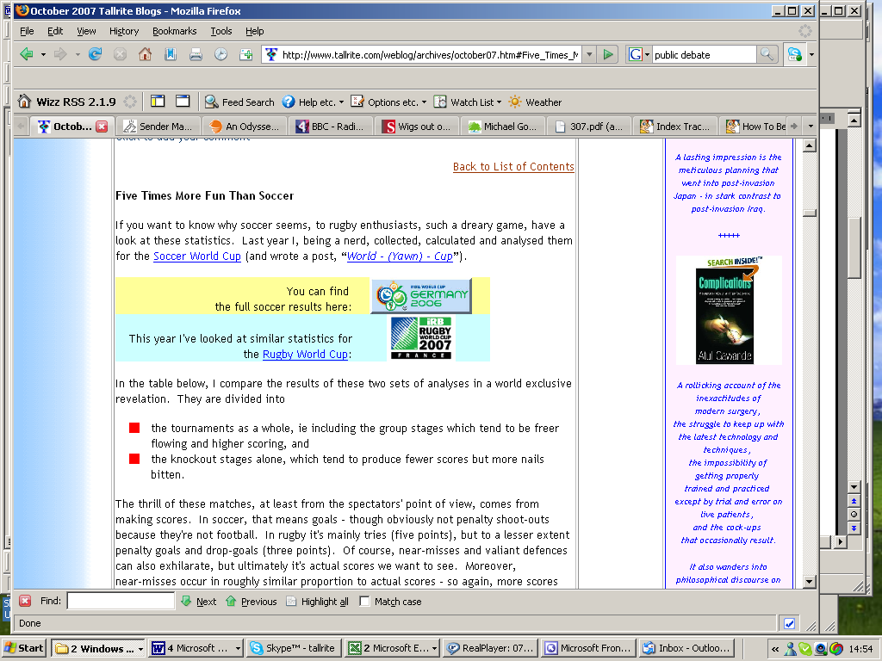
According to conservative radio jock Hugh Hewitt (minutes 10-12 in this audio clip), the White House recently reported the following as of 18 October, with regard to a 93 sq km sector of north-west Baghdad with a population of a million people, a sector controlled by the US army –
- There has been 85% reduction in violence since May.
- 58 of 95 “mahallas” or neighbourhoods are now under “control”, with 33 in “clearing” status.
- Murders are down from 161 per week a year ago to less than five per this year.
- IED and small arms attacks are down from 50 per week in June to under five per by the end of August.
- Vehicle-born IEDs are down by nearly 85%.
US forces are partnered by ten Iraqi army battalions and two national police battalions across the security districts of Mansour and Katayama. These areas are commanded by highly competent patriotic Iraqi brigadier generals who are consistently demonstrating their unbreakable will to deliver security, reconciliation and reconstruction to NW Baghdad.
But that is not to deny that dreadful news is happening in parallel, most recently the murder of 24 Iraqi police officers and recruits in Baquba, north-east of Baghdad.
I wish I had a better handle on the balance of positive and negative news.
Five Times More Fun Than Soccer
If you want to know why soccer seems, to rugby enthusiasts, such a dreary game, have a look at these statistics. Last year I, being a nerd, collected, calculated and analysed them for the Soccer World Cup (and wrote a post, “World - (Yawn) - Cup”).
In the table below, I compare the results of these two sets of analyses in a world exclusive revelation. They are divided into
- the tournaments as a whole, ie including the group stages which tend to be freer flowing and higher scoring, and
- the knockout stages alone, which tend to produce fewer scores but more nails bitten.
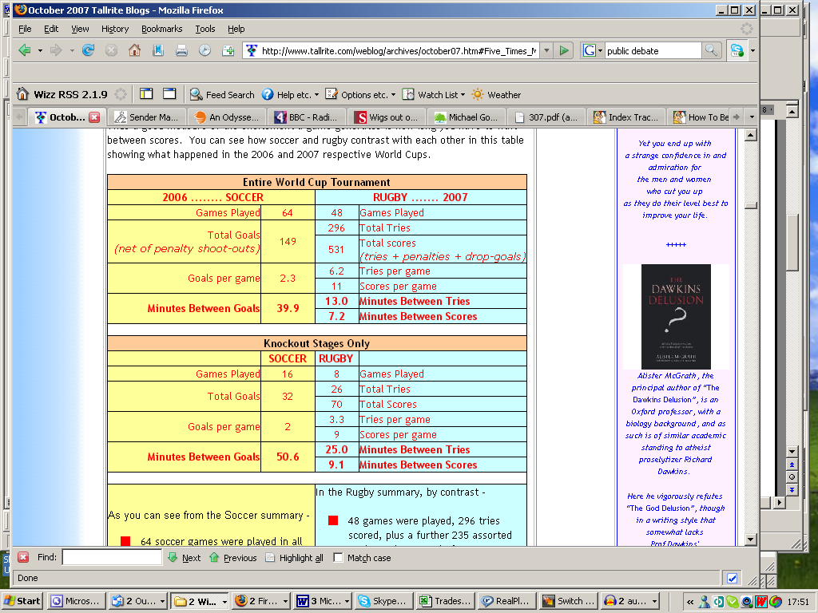
The thrill of these matches, at least from the spectators' point of view, comes from making scores. In soccer, that means goals - though obviously not penalty shoot-outs because they're not football. In rugby it's mainly tries (five points), but to a lesser extent penalty goals and drop-goals (three points). Of course, near-misses and valiant defences can also exhilarate, but ultimately it's actual scores we want to see. Moreover, near-misses occur in roughly similar proportion to actual scores - so again, more scores mean more near-misses mean in aggregate more fun.

Thus a good measure of the excitement a game generates is how long you have to wait between scores. You can see how rugby and soccer contrast with each other in this table showing what happened in the 2006 and 2007 respective World
As you can see from the Soccer summary -
- 64 soccer games were played in all and 149 goals scored (excluding 24 penalty shoot-out goals). That works out at just 2.3 goals per game or one goal per forty minutes.
- And if you look only at the knockout stages, the averages drop to just two goals per game or one goal per miserable 51 minutes, ie not even one per half.

Talk about a snoreathon.
In the Rugby summary, by contrast -
- 48 games were played, 296 tries scored, plus a further 235 assorted goals to give a total of 531 scores. That averages out at a scintillating 6.2 tries per game (not counting the penalty goals and drop-goals) and just seven minutes between scores.
- And looking only at the knockout stages, the averages certainly drop, but to
- a still respectable 3.3 tries per game and nine minutes between scores.

Not much chance for dozing off, then.
So in the final analysis, it's 51 minutes versus nine. You can therefore see how, broadly speaking, rugby is five times more fun to watch than soccer.
So why is soccer not rugby the world's most popular ball game, and by a mile? I have no idea. It makes no sense to me at all.
Meanwhile, I await the next World Cup with bated breath - the Seven-a-Side Rugby World Cup, to be held in a single stadium over a single long weekend in February 2009 in Dubai. In this fast, furious and foreshortened version of the game, scores will mount up at an even more astonishing rate, measured more in seconds than in minutes. Be there!
New Wine for Seniors
(Hat tip: David in Fuengirola)
California vintners in the Napa Valley area, which primarily produce Pinot Blanc, Pinot Noir and Pinot Grigio wines, have developed a new hybrid grape that acts as an anti-diuretic.

It is expected to reduce the number of trips older people have to make to the bathroom during the night.
The new wine will be marketed as ...
“PINO MORE”

I heard it through the grapevine. [Groan - Ed].
Issue 164's Letters to the Press
Neither letter published this week, despite my usual witterings.
- EU Reform Treaty Referendum
- to the Irish Times
Madam, - The Reform Treaty is “a vote for climate change, a vote for environmental policies, a vote for the Common Agricultural Policy, a vote for social Europe, that is a vote for the reform treaty” says Bertie Ahern to convince the Irish to vote yes in a referendum. This is of course the document which he has already told us is 90% the same as 90% the same as the Constitutional Treaty (Ireland, June 25th) soundly rejected by French and Dutch voters in 2005.
Unwittingly, however, Mr Ahern succinctly lists all the reasons to vote no this time around! - Yours etc,
- Dog-whistling Floor Space
- to The Economist
Sir, - Yasser Arafat used to say one thing in Arabic to please his robust Middle Eastern audiences and quite the opposite in English to placate delicate Westerners. Some politicians prefer the dog-whistle technique to speak different messages to different listeners.
Are you doing something similar over a Planned Parenthood facility in Aurora, Illinois? (“Creative Construction”, October 13th)? You say it occupies just 22,000 square feet, presumably for the benefit of your angry red-state readers who think this is already too large, but three times bigger - 6,700 square metres - for your more liberal, metric-speaking Europeans. - Yours etc,
Quotes for Issue 164
- - - - - - - - - - J I H A D - - - - - - - - - -
Quote: “There is a tendency ... to believe [the Iranian regime] are as they are because we have provoked them and if we left them alone they would leave us alone. I fear this is mistaken. They have no intention of leaving us alone.”
Tony Blair, warmongering as ever,
earns four standing ovations
from his Blairophilic American audience
Quote: “The US administration is like a madman running around with a razor blade.”
President of Russia, Vladimir Putin,
in typically feisty form,
denounces America for demonising and imposing sanctions on Iran,
and wanting to erect an anti-Iran missile shield
in Poland and the Czech Republic
- - - - - - - - - - E U R O P E - - - - - - - - - -
Quote: “[It is] a vote for climate change, a vote for environmental policies, a vote for the Common Agricultural Policy, a vote for social Europe, that is a vote for the Reform Treaty.”
Bertie Ahern, Ireland's Taoiseach
(prime minister),unwittingly lists
all the reasons to vote against the
euphemistically re-named “Reform Treaty”,
to be euphemistically re-re-named
the “Lisbon Treaty”.
It is of course, as Mr Ahern noted last June,
90% the same as the “Constitutional Treaty”
which was soundly rejected
by French and Dutch voters in 2005.
Fearful of further popular rejection,
no other state but Ireland will subject the latest version to a referendum.
Constitutionally, Ireland has no choice.
Quote: “I could kill you as easy as spit on you.”
Poland's former Prime Minister
Jaroslaw Kaczynski, one of the indistinguishable “potato twins”,
pulls a gun on his rival Donald Tusk
in a parliamentary corridor.
Or so Mr Tusk,
in a pre-election TV debate,
alleged occurred in the 1990s.
Mr Tusk soundly defeated Mr Kaczsynski
in the general election last week.
But how does he know it wasn't
Poland's president Lech Kaczynski
who brandished the gun?
Quote: “I hope you won't be giving grants to too many one-legged Lithuanian lesbians.”
Tory would-be prime minister
David Cameron
sensitively suggests that lottery funds
should be more carefully targeted.
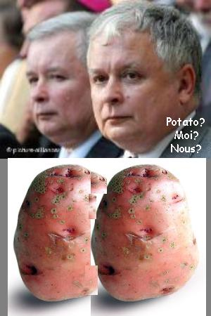
“I thought we just have, haven't we?”
Arts Council chairman
Sir Christopher Frayling replies
Meanwhile, one-legged Lithuanian lesbians are outraged.
- - - - - - - - - - I R E L A N D - - - - - - - - - -
Quote: “That's bullshit. Nobody saw me. I had a balaclava and gloves!”
Killer and serial thug Leigh Crowe,
on learning he had been identified when,
at a house party in Tipperary,
he shot Owen Cahill in the face killing him,
shot Mark Doolan in the arm,
and assaulted Sharon Rossiter.
However, this rum defence
did not stand up in his trial.
Happily, Mr Crowe was sentenced to life
for manslaughter (manslaughter?
Why not murder? I don't know).
He also got 15 years for attempted murder (not attempted manslaughter?)
plus five years for the assault.
The murder/manslaughter law
works in curious ways.
Quote: “I do wish I did come to Dublin more often - to evangelise the heathens.”
Rev Ian Paisley, First Minister of Northern Ireland and rabid Protestant,
with tongue firmly in cheek,
on a visit to the Historical Society of
Trinity College Dublin,
in holy Catholic Ireland
- - - - - R U G B Y W O R L D C U P - - - - -
Quote: “The [England world cup rugby] squad spent yesterday in recovery mode, the physios kept busy nursing bruises, many of them caused by players pinching themselves.”
Daily Telegraph journalist Mick Cleary,
commenting on England's unbelievable [sic] progress to the World Cup final,
just after defeating France against all odds.
Quote (heard in a Sky News interview): “Blimey, it can't happen to us, can it, what happened to them [Australia and France]. Can it?”
England rugby coach Brian Ashton
tries to imagine what was going
through the minds of South Africa
in the lead-up to the World Cup Final
between these two mighty teams.
Whatever they were actually thinking, it worked.
South Africa are the new World Champions
Quote : “They say in politics a week is a long time, but in rugby, I tell you, 80 minutes is a fantastic thing.”
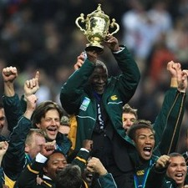
Jake White, manager and coach of
the South Africa rugby team,
reflects on the final against England
that won him the Rugby World Cup,
the Webb Ellis Trophy.

